Alan Boyle | alan@cosmiclog.com
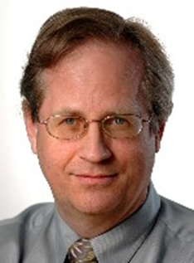
P R O F E S S I O N A L E X P E R I E N C E
2015 - GeekWire Seattle, WA
Aerospace and Science Editor (2015 to 2020);
Contributing Editor (2020 to present);
also Contributing Writer for Universe Today.
1996 - 2015 NBC News Digital Seattle, WA
Science Editor (1997-2015); Writer/Editor (1996-1997).
1984 - 1996 Seattle Post-Intelligencer Seattle, WA
Foreign Desk Editor (1987-96); Features Copy Chief (1985-87); Copy Editor (1984-85).
1978 - 1984 The Spokesman-Review Spokane, WA
Features Editor (1980-84); Assistant City Editor (1979-80); Copy Editor (1978-79).
1977 - 1978 The Cincinnati Post Cincinnati, OH
Copy Editor.
P R O F E S S I O N A L A C T I V I T I E S
Awards include:
- Von Braun Communications Award, National Space Club – Huntsville (2014).
- National Academies Communication Award (2008, online/Internet category).
- IEEE-USA Award for Distinguished Literary Contributions Furthering Public Understanding of the Engineering Profession (2008).
- June Anderson Almquist Award for Distinguished Service to Journalism, Society of Professional Journalists, Western Washington Pro Chapter (2007).
- CMU Cybersecurity Journalism Award (2003, co-winner, online category).
- AAAS Science Journalism Award (2002, online category).
- NASW Science in Society Award (2002, online category).
Other distinctions:
- Author of "The Case for Pluto: How a Little Planet Made a Big Difference." John Wiley & Sons, 2010. Contributor to "A Field Guide for Science Writers" (2nd ed., Oxford, 2006).
- Board member, Council for the Advancement of Science Writers (2005-present); President from 2013 to 2021.
E D U C A T I O N
1977 Columbia University, New York, NY: M.S., Journalism, Lydia C. Roberts Fellow
1976 Loras College Dubuque, IA: B.A.., English, Writing and Philosophy, Maxima Cum Laude

